**CS372 Exam: Jan 2017 (100 points)**

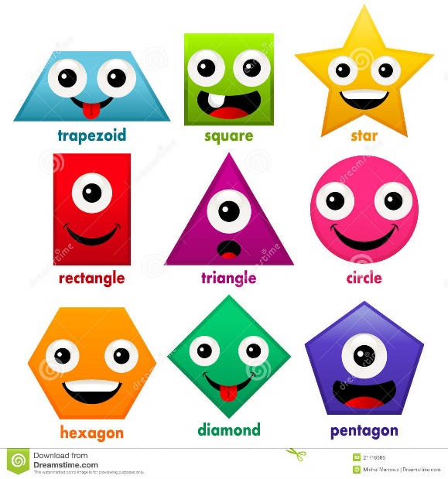Everyone loves shapes, and everyone loves geometry! And looking at shapes and understanding their properties is very important. We need a program that can show a variety of shapes to the user, and when they click on a shape, they can see the shape in some detail and see some specific properties of that shape.

So, you will be given a file (.txt or .xml). That file will contain a collection of four different shapes: circle, square, rectangle, and triangle (and OK math majors, I know that a square is a rectangle, so maybe “different” was a stretch). We need you to list the objects (with their IDs) on the left-hand side of the UI. When the user clicks on a specific shape, we want you to display that shape along with specific properties, including area and perimeter. See below for a mockup:

|  |  |
| --- | --- |
| Circle (0)  Square (100)  Square (101)  Rectangle (200)  Triangle (300)  Square (102)  Triangle (301)  Circle (1)  Square (103)  Circle (2) | http://4.bp.blogspot.com/-lRwkholfrPo/UqAm23Rtq0I/AAAAAAAAAHU/vSpYYJcTf0s/s1600/1.pngRectangle (ID# 200)  Color: yellow  Length: 7  Width: 8  Area: 56  Perimeter: 30 |

You are free to use any image you wish for the images (and they obviously don’t have to match the color or properties). The shapes are listed in both a .txt file and a .xml file. You will need to read the data into your program before you display the shapes. We may want to add more shapes at a later time, so you can’t simply hardcode each shape into your code. You can choose which file to read from – they contain the same data.

You are also expected to use the following class hierarchy, though you can add functions and variables to the classes as you see fit:

interface Shape

+String toString()

+String getKind()

+String getDetailString()

+int getID();

Circle

Triangle

Rectangle

Square

For the Shape interface:

* toString would return the kind and ID of the shape (e.g. “Circle (ID# 1)”)
* getKind would return the kind of shape (e.g. “Circle”)
* getDetailString would return the details of that shape (including kind, ID, properties, area, perimeter) – what would be displayed in the right hand side panel in the mockup above
* getID would return the ID of the shape

Below is the grading rubric I will use:

|  |  |
| --- | --- |
| Program Feature | Percentage |
| Read from the file correctly | 20% |
| Implement class hierarchy correctly | 20% |
| Populate appropriate data structures with shape data | 20% |
| Show list of shapes correctly | 20% |
| Show specific shape properties correctly | 20% |

Save your solution to your GitHub repository.